**Report For Runlinc**

**(A case study for Line on/off Buttons)**

By

Afolayan Oluwatimilehin Israel

080-452

**Introduction**

Two buttons on a web page can be used to control anything anywhere, like lights on your porch so you can see, or scare off intruders. Using runlinc we can program a microchip to remotely turn on a security light.

**Visual Content**

Screenshot of the HTML, CSS and JavaScript code

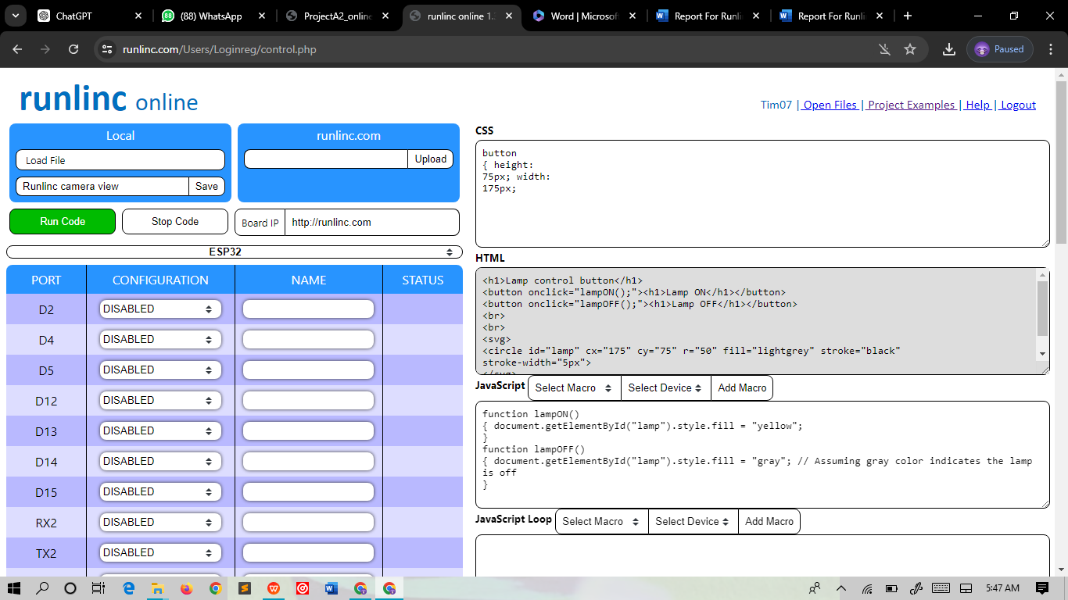

**CSS code:**

button

{ height:

75px; width:

175px;

**HTML code**

<h1>Lamp control button</h1>

<button onclick="lampON();"><h1>Lamp ON</h1></button>

<button onclick="lampOFF();"><h1>Lamp OFF</h1></button>

<br>

<br>

<svg>

<circle id="lamp" cx="175" cy="75" r="50" fill="lightgrey" stroke="black"

stroke-width="5px">

</svg>

**JavaScript Code**

function lampON()

{ document.getElementById("lamp").style.fill = "yellow";

}

function lampOFF()

{ document.getElementById("lamp").style.fill = "gray"; // Assuming gray color indicates the lamp is off

}

**Screenshots of Output**

Lamp on

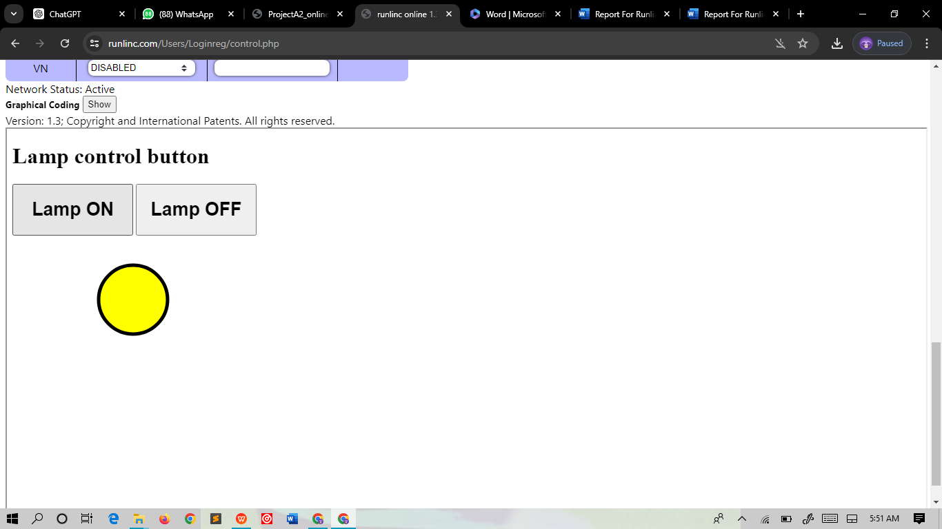

Lamp off

